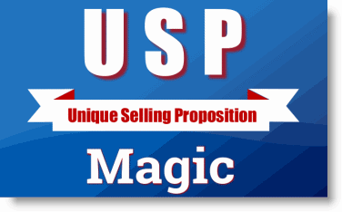
REPORT #2
The Four Numbered Safe - Five Keys To Successful Integration of Your USP

A step by step marketing system for continued guaranteed exponential growth in sales and profits

We reviewed the top two marketing steps your company should not be found without.
Step one: Uncovering and Creating a USP – Unique Selling Proposition
Step two: Integrating and communicating that USP.
We learned that those two steps alone can propel your company to a 20-100% or more increase in sales and profits. Without asking you to spend more money on traditional marketing/advertising. And, that this can happen in as little as 60-90 days. Guaranteed.
Now, if you’ve successfully started with these two steps, you’re ready to complete your 21st Century Marketing System. Steps three and four:
STEP THREE: Database marketing with your new USP
STEP FOUR: Alliance marketing with your new USP
There are several reasons you want to finish the system:
- Complete optimization and leveraging of ALL marketing assets/opportunities. The 21st Century Marketing System is unique. It is an asset based marketing approach. Not a traditional marketing approach. It grows sales and profits for a company by better optimizing and leveraging marketing assets already found within the company. No new marketing expenses or investments are required. However, steps one and two leverage only some of those assets. The good news is that with some of those assets leveraged very well, significant, even exponential growth can take place. But adding the rest of the 21st Century Marketing System more fully optimizes and leverages all of your company marketing assets for even more exponential growth. And, it puts into place a “complete system” of marketing that can continue that growth.

- Grow your business three ways instead of just one. Traditional marketing is all about growing your business one way – increase the number of prospects contacted. With implementation of all four steps in the 21st Century Marketing System, you’ll be growing your business all three ways:

- Increase the number of prospects contacted (Steps one and four alliance marketing with your new USP)
- Increase the conversion rate of prospects to paying customers. (Steps one and two)
- Increase the value or worth of each customer. (steps one and three – database marketing with your new USP.
The graph below illustrates the power of all three ways to growing compounding the growth in sales and profits.
Because of all four steps, you’ll being systematically growing your sales and profits three ways instead of just one. That is what makes the 21st Century Marketing System unique: It is the only marketing system that simultaneously grows sales and profits ALL THREE WAYS!

That’s why it’s successful record of creating exponential growth!
Let’s discuss in a little bit more detail steps three and four:
STEP THREE: Database marketing with your new USP.
There are three groups of customers in your business. Past customers. Present customers. Prospective customers. How often do you communicate with them? How well do you follow-up with prospective customers? Do you have an "auto-responder" follow-up system? Do you capture contact information of prospects from your website? Do you try to reactivate past customers and bring them back to your business? Especially with a new USP? Customers need to understand clearly why they should do business with your company. If you don't have a USP, they will shop with their wallets and shop for the lowest price.
Do you regularly try to get current customers buying from you again and again? Most customers leave a business because they get a feeling of "apathy" from the business. Do you understand the lifetime value of your customer? Can you beat the competition at keeping your customers loyal to you? Are your sales dependent upon the salesperson or do they buy your company USP? Good database marketing with a strong USP will increase the value or worth of your customers to your business and contribute to exponential sales.
Communicating your USP with a specific offer and call to action will optimize your marketing efforts. Feedback from customers will also tell you when your USP might need to change. They often tell you what the competition is doing and that feedback is most important in keeping your USP current. Dominos pizza had a great USP twenty or so years ago when they offered to deliver your pizza in 30 minutes or it's free. Soon, all other pizza companies were delivering pizza in under 30 minutes. It is no longer a USP. Dominos needs to change their USP. Will they? What's their new one?

STEP FOUR: Alliance and partnership marketing with your new USP.
Again, the order of these steps and the execution of each tactic within the steps is what makes The 21st Century Marketing System so powerful and unique. Traditional marketing's first focus is more leads. Here, it is last. There's a reason. Why would you go get more leads and prospects if you're not managing and leading the current prospects well by implementing steps one, two and three? Why waste more money? If you're marketing/sales system is broken don't waste more money on more leads!
Put the first three steps in place first. Then, go find more leads. Only this time do it with alliances and marketing partnerships. Get affiliate partners on the web marketing for you. If you have dealers and distributors, do more partner marketing with them. Teach them the three ways to grow. Help them make more money and they will perform better for you.
Search out from your customer base those that might have customers you want. Ask them for an endorsement to their customers. Endorsements are a powerful way to attract new prospects. Identify complementary businesses that have customers you want. Form a marketing alliance with them to promote your products/services to their customers. In return they can promote their products/services to yours. You're optimizing the marketing assets of relationships and trust to generate more prospects.
Don't do partner or alliance marketing with businesses that don't accept or believe in your USP.
The graph below illustrates all four steps working together to create a 21st Century Marketing System for your company that can create on-going exponential growth in your sales and profits.
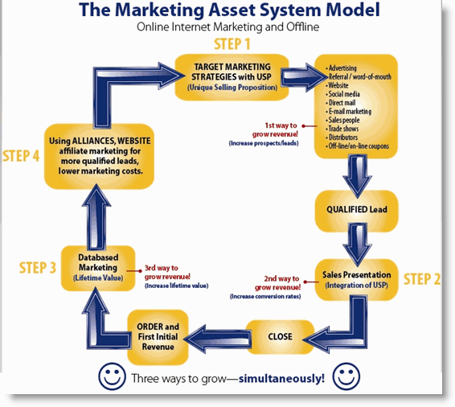
These four steps should be your marketing plan. Every marketing strategy know can fit under one of these four steps. Before you do any other marketing, make sure these steps are in place. Otherwise, you're wasting marketing dollars. You're missing out on a lot of cash that could be yours. The opportunity cost of not executing successfully these four marketing steps is huge. You don't want to afford that.
Contact us now to find out how much more your company sales and profits can GROW.
E-mail me directly at: Richard@USPMagic.com and I’ll be happy to tell you what I think. Or call me directly at.
Contact us now to find out how much more your company sales and profits can grow with a proper USP and one that’s successfully executed.
Go to our website at: www.USPMagic.com
Call us directly at 1-801-889-1505
Or e-mail Richard directly at: Richard@USPMagic.com
Remember: Every minute that goes by without a unique selling proposition in place is costing you thousands if not millions of new dollars for your business.

