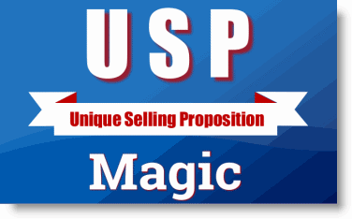
REPORT #1
How To Discover Your Most Valuable Marketing Asset - Getting Started.
As I work daily with small businesses of all industry – retail, wholesale, professional, service and manufacturing there is one fact that stands out above all others – 99% of them do not have a USP – Unique Selling Proposition.
I love the quote from one of my marketing mentors, Jay Abraham:
Jay Abraham, a marketing consultant who once described himself as “the most expensive and successful marketing consultant on the planet”, said that most businesses do not have a USP:
[They have] only a “me too”, rudderless, nondescript, unappealing business that feeds solely upon the sheer momentum of the marketplace. There's nothing unique; there's nothing distinct. They promise no great value, benefit, or service—just “buy from us” for no justifiable, rational reason. (The Economist, 2009)
Jay is right. As long as the natural economy grows, most companies can grow. But, if the economy stalls or declines, companies without differentiation or a strong USP will suffer and likely go out of business.
When the economy stalls or the economic pie contracts, the only source for your company’s growth is to take away market share. Take a bigger piece of the pie. If you want to break free of dependence on the natural economy and create your own economy you can with the TOP TWO MARKETING STEPS. If you want to propel your company’s sales and profits exponentially – 20%-100% or more and do so quickly – in as little as 60-90 days, it can be done with the TOP TWO MARKETING STEPS:

STEP ONE: Uncover and create a USP – Unique Selling Proposition.
Since 1990, 21st Century Marketing Systems, Inc. and over 200 affiliated consultants from around the world have adopted the following definition of a USP.
In the book Differentiate or Die, author Jack Trout credits Rosser Reeves with coming up with the USP idea and says there are three parts to the definition:
- Each advertisement must make a proposition to the consumer and say to each reader: “Buy this product, and you will get this specific benefit.”
- The proposition must be one that the competition either cannot, or does not, offer.
- The proposition must be so strong that it can move the mass – pull over new customers to your product – in other words, take away market share from your competitors.
And, as defined in Wikipedia:
The unique selling proposition (USP), or unique selling point, or "'unique selling product"' or "' unique selling price"' is a marketing concept first proposed as a theory to explain a pattern in successful advertising campaigns of the early 1940s. The USP states that such campaigns made unique propositions to the customer that convinced them to switch brands. The term was developed by television advertising pioneer Rosser Reeves of Ted Bates & Company. Theodore Levitt, a professor at Harvard Business School, suggested that, "Differentiation is one of the most important strategic and tactical activities in which companies must constantly engage."[1]
Does your business have a USP? I would challenge you and declare that 99 out of 100 do not have one. They might have a slogan, tag line or mission statement hanging on the lobby wall or headlining their web home page. These are not USPs. Prospects and customers don’t care about your mission.
A USP should fill a void. It should matter to the customer. A slogan might introduce a USP. Lenscrafters – in about an hour. Great USP. Walmart owns the low price USP. Target can build a store right next to Walmart and do great. Why? Different USP. Target goes after a different customer than Walmart. Kmart has been trying to compete with Walmart and is losing. One night I saw a commercial that said: “Kmart – the stuff of life.” Wow, now that’s unique! A USP is not claiming you have good quality. That’s expected. It’s not good customer service. That’s expected.
Other pioneers in the use of a USP:
Dominos Pizza: Delivered in 30 minutes or it’s FREE.
FEDX: Absolutely, positively overnight.
Southwest Airlines: The low price airfare airline.
Websites today with good USPs:
Nerd Fitness: Like Target, the USP is in who they are going after
Toms Shoes: A new pair of shoes to a child in need for every pair you purchase.

A USP MIGHT MEAN INNOVATING DEMAND

Sometimes, you might have to innovate demand to create a USP. Papa Murphy’s pizza – bake your own. That’s a USP. Instead of competing on Pizza, they shift our demand away from buying pizza to baking our own. Do you need to innovate demand? Actually change the way a customer thinks about a product?
If you accept the above definition of a USP, then you’ll see there is a lot of hard work that goes into a successful USP:

THIS IS WHAT SEPARATES 21st CENTURY MARKETING FROM ALL OTHER MARKETING AND OR AD AGENCIES: ASSET BASED MARKETING THINKING
Most traditional marketing or advertising firms have a visit with the owner and top management of a company. They ask them why they think their company is so good? Then, they create a slogan or “brand” around that.
Coming up with a good USP requires much more. Within every business are marketing opportunities or marketing assets. These include: owner expertise, staff and employee expertise, time in business, credibility, performance, policies and procedures, customer service, current marketing and sales processes, current customers, average customer sale, conversion rate, prospective customers, past customers, location, customer retention rate, and more.
When those assets are considered carefully, there is often a USP hiding. It’s just not getting articulated or packaged in a way that matters to the customers and prospects. An Asset based marketing approach digs into those assets and finds ways to leverage or optimize them for more money. And, that all starts with a strong USP.
At 21st Century Marketing Systems, Inc. we consider ourselves the “differentiation experts.”
WARNING: BRANDING IS NOT NECESSARILY A USP! BUT A GOOD USP CAN BECOME A BRAND AND OWN A POSITION IN THE BUYER’S MIND
A good brand may not sell anything! A good USP will not only sell, but over time can create a strong brand and position in the minds of buyers.
Consider:
Toyota: Reliability
Visa: Everywhere
BMW: Performance
Crest: Cavity Prevention
Science Diet: Preferred by Vets
These companies own these attributes that have turned into effective USPs and strong market position.
The next step is to consider your customer’s perspective. What do they feel is missing in the marketplace? Can they identify a void? Why did they choose you over the competition?
What matters to them?
But, what the owner and employees think and what the customers think do not by themselves determine an accurate USP. The most important consideration is the competition! Can they or will they sell what you can or will? What is their USP? Do they have one?
Can you differentiate? If the owner and staff think there is a certain USP and the customers report a certain USP but the competition does it, then it isn’t a USP!
FINALLY – IT MUST BE BOLD, OVERT. MOVE THE MASSES!
A USP will not work if it isn’t bold, overt and strong enough to move the masses. Remember, if you want to create your own economy and not rely on the “natural economy” you must be able to take away market share – move the masses over to your product/service. And, of course, your company must be able to deliver on it. But, often adopting one can make your company better, more competitive, stronger and sharper!
And, USPs will change. They change as often as the competition catches up. That makes it better for everyone. We all benefit. Your company gets better, sharper. Customers get a better product or improved service. So, you should revisit your USP every year. Check on it. Update it. Make it more relevant. Stronger. Bolder.
After you have determined your USP , you’re ready for TOP STEP NUMBER TWO: Successful integration and communication of the USP!

STEP TWO: Successfully integrating and communicating the USP – Unique Selling Proposition

This second top step is all about execution. Once you have your USP determined, you must be able to execute on it and communicate it over and over and over again.
It should immediately be integrated into your company’s sales and marketing processes. This starts with all promotional material and websites. Banner ads. Headlines. Shows. Events. Presentations of all sales representatives. Presentations of your website. As the graph below illustrates, all current marketing strategies, tools need to integrate the USP.
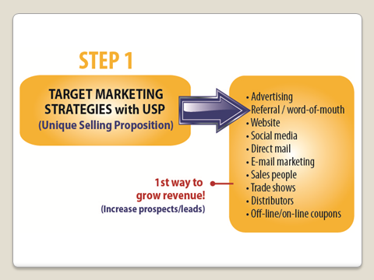
Success has come to almost every client situation where once a USP is determined and the salespeople catch fire and sell it, the company wins. There can be exponential growth just with these two steps!
OTHER DEPARTMENTS
It is very important that not just the sales department get on board with the USP. Customer service, operations, shipping, accounting and all other departments in the company must be on board with executing on the USP. Many or all of them will have been involved in helping determine one. Any one department can “kill” the execution of a USP.
Below is a graph of a marketing/sales process within a company. Every company has some version of this process. It’s the individual steps within the process that are often weak. That is a purpose of the USP – making each part of the sales process stronger so that conversion of prospects to customers is better.
Increasing the conversion rate of prospects to paying customers within any company by 5-10% can result in exponential growth – in both revenue and profit.
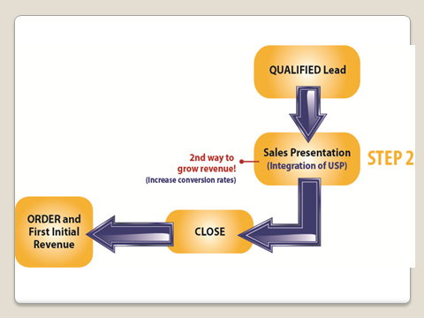

A good USP is the most effective way to qualify a lead. Many companies lose thousands of dollars in wasted resources as salespeople work with unqualified leads.
Prospects that don’t care about your USP.
In one client case, as the salespeople got better at integrating the USP into their sales process and used it to better qualify leads, the conversion rate increased 80%
This can happen in your company as well.
Each of the above steps must integrate and communicate the USP over and over and over again.
If sales management fails to get this accomplished, the chance for exponential growth in sales and profits is diminished.
Whether the above marketing/sales process is off-line, on-line or both, the USP must be successfully integrated into the process.

WHAT ABOUT UNCONVERTED PROSPECTS?
Just because a prospect says “no” to your offer today, doesn’t mean they won’t need or want it down the road. Many companies lose a lot of money with failure to follow-up the sales process and communicate again the USP to those that didn’t buy the first time.
This is a HUGE marketing mistake. Today, technology is such that an automated follow-up is easy. Every qualified prospect should be in a customer relationship management system of some sort that automates follow-up. New messages. New offers. New Headlines. New copy. All of these can be tested and changed to see what might attract a former prospect to sign up today.
With successful follow-up with another client, the company enjoyed a cash increase of over a million dollars in one year.
DON’T DO ANY MORE MARKETING WITHOUT THESE TWO STEPS IN PLACE!
WHY?
Because you’ll be wasting thousands of dollars in time, money, employee effort and other resources.
The 21st Century Marketing System’s approach to marketing is all about optimization and leveraging of marketing assets/opportunities. The USP is step one in successfully optimizing and leveraging your company assets. Integration and communication of that USP is step two.
Then, do all the other marketing you want! I’m in favor of doing all the marketing you can once these two steps are in place. To do any marketing without these two steps in place is costing you thousands if not millions of dollars in not only the hard costs of marketing, but the opportunity cost especially.
If you think your company has a USP, take me up on my bet! Let me know.
E-mail me directly at: Richard@USPMagic.com and I’ll be happy to tell you what I think. Or call me directly at.
Contact us now to find out how much more your company sales and profits can grow with a proper USP and one that’s successfully executed.
Go to our website at: www.USPMagic.com
Call us directly at 1-801-889-1505
Or e-mail Richard directly at: Richard@USPMagic.com
Remember: Every minute that goes by without a unique selling proposition in place is costing you thousands if not millions of new dollars for your business.

